*Heaven’s Light is Our Guide*



**Course No:** CSE 4108

**Course Title:** Sessional based on CSE 4107

**System Analysis and Design of ‘Rajshahi Sugar Mills Ltd.’, Katakhali.**

**Submitted To:**

Emrana Kabir Hashi

Assistant Professor

Department of Computer Science and Engineering

Rajshahi University of Engineering and Technology

**Submitted By:**

|  |  |
| --- | --- |
| **ROLL NO** | **NAME** |
| 1703146 | Md. Nazmul Hossain Anik |
| 1703147 | Nadia Subrin |
| 1703148 | Md. Rakibul Nayeem |
| 1703149 | Md. Mohiuddin Ahmed |
| 1703150 | Joytun Sultana Mita |

**Date of submission:** 29 November 2022

**Table of Contents**

**Chapter 1: Introduction ………………………………………………………….……………………….………………. 1-5**

1.1 Outset ……………………………………………………………………………..…………………………….…… 1

1.2 Rajshahi Sugar Mills Ltd.(Haryana Sugar Mills)…………………………..………………..………. 1-2

1.3 Objectives ………………………………………………………………………….…………………….….……… 3

1.4 Activities …………………………………………………………………………………………….……….….…… 3

1.5 Vision and Mission ………………………………………………….….…….………….….…………………. 4

1.5.1 Vision …………………………….………………………….….……………….….…….…………… 4

1.5.2 Mission …………………………………….…………………….…………..…..…………………….4

1.6 Hierarchy ……………………………………………………….…………….…………….…...……………….… 5

1.7 Reputation ……………………………………………………….…………...……………..….…………….…… 5

1.7.1 National .………………………………………………..…………..……….…….…………….…… 5

1.7.2 International ………………………………….………………….………….….………………..… 5

1.8 Conclusion …………………………………………………………………………………..……………...……… 5

**Chapter 2: Systems Planning and Initial Investigation……………………………….……………….…... 6-9**

2.1 Introduction ……………………………………………………………………………………………….……… 6

2.2 Initial Investigation …………………………………………………………………………….……………… 7-8

2.2.1 Request of Changes ……………………………………………………………….………...… 8

2.3 Need Identification …………………………………………………………………………….……………… 9

2.3.1 Verify Request of Changes …………………………………………………….…..……….. 9

2.4 Conclusion…………………………………………………………………………………………….……….…… 9

**Chapter 3: Information Gathering and Analysis** **………………………………………………….…….….10-28**

3.1 Introduction ……………………………………………………………………………………………..…… 10

3.2 Information Gathering

3.2.1 Literature Review, Procedures, Forms ………………………………………..….. 12-14

3.2.2 On-Site Observation………………………………………………………………………… 14

3.2.3 Interviews ………………………………………………………………………………………..15

3.2.4 Organization hierarchy………………………………………….………………………….15-16

3.2.5 Factory hierarchy……………………………………………….……………………………. 16

3.3 Sample Questionnaires ……………………………………………………………………………..…… 16-27

3.4 Conclusion …………………………………………………………………………………………………….. 28

**Chapter 4: The Tools of Structured Analysis** **…………………………………………………….…………. 29-32**

4.1 Introduction………………………………………………………………………………..…………………. 29

4.2 Data Flow Diagram…………………………………………………………………….…………………… 30

4.3 Decision Tree ………………………………………………………………….……………………………… 31

4.4 Data Dictionary …………………………………………………………………..…………………………. 31

4.5 Conclusion……………………………………………………………………………………………….………. 32

**Chapter 5: Feasibility Analysis ………………………………………………………………………………….….. 32-41**

5.1 Introduction …………………………………………………………………………………….….………….. 32

5.2 Initial Feasibility Study……………………………………………………………………………….…….. 32

5.3 Feasibility Considerations ………………………………………………………………..……….…..… 33-34

5.3.1 Economic Feasibility…………………………………………….……………………... 35

5.3.2 Technical Feasibility…………………………………..………………………………... 35

5.3.3 Behavioral Feasibility………………………….……………………………………….. 36

5.4 Here are our initial system analysis’s findings at Rajshahi Sugar Mills Ltd………… 36-37

5.4.1 Current System’s needs and proposed system's approach to meet them

5.4.2 Candidate System-1………………………………………………………………..…... 38

5.4.3 Candidate System-2……………………………………………………..……………... 38

5.5 Identifying the Characteristics of Candidate Systems………………………..…………….. 39-40

5.5.1 Characteristics of two potential Candidate System……………………... 39

5.5.2 Qualitative Evaluation Matrix………………………………………………………. 39

5.5.3 Performance/Cost Evaluation Matrix…………………………….…………….. 39

5.5.4 Weighted Candidate Evaluation Matrix…………………………..…………… 39

5.5.5 Selecting Best Candidate System…………………………………………………. 40

5.5.6 DFD (Data Flow Diagram) for best Candidate System…………………… 40

5.6.1 Available Resources for Proposed Candidate System…………………………….………… 41

5.6.2 Impact of the proposed System……………………………………………………………..……….. 41

5.7 Conclusion………………………………………………………………………….………………………………. 41

**Chapter 6: Cost-Benefit Analysis ………………………………………………………….………………………. 42-45**

6.1 Classification of Costs and Benefits…………………………………………………………………… 42

6.2 Break-even Analysis and Operating Leverage…………………………..………………….…… 42-43

6.2.1 Break-even Analysis………………………………………………………..……........ 42

6.2.2 Operating Leverage………………………………………………………..…………… 43

6.3 Categorization of Costs of Benefits………………………….……………………………………….. 43-44

6.4 Conclusions ………………………………………………………………………………………………........ 45

**Chapter 7 : The Process and Stages of System Design……………………………………………………… 46-56**

7.1 Introduction…………………………………………………………………………………………..…………… 46

7.2 The Process of Design…………………………………………………………………….…………………. 47-49

7.2.1 Logical System…………………………………………………..……………………… 48

7.2.2 Physical Design………………………………………………………….…………….. 48-49

7.3 Structured Design……………………………………………………………...……………………………… 50-52

7.4 Structure Chart………………………………………………………………………………………………..... 53

7.5 Data Table………………………………………………………………………………………………………….. 54

7.6 E-R Diagram……………………………………………………………………………………………………….. 55

7.7 Conclusion………………………………………………………………………………………………….…...... 56

**Chapter 1**

**Introduction**

**1.1 Outset**

The purpose of this paper is to present an analysis over the organization we  
were assigned to analyze and design. We have worked on analyzing Rajshahi  
Sugar Mills Limited also known as Haryana Sugar Mills. It is a government  
organization which is under Bangladesh Sugar & Food industries Corporation.  
They have worked for more than 60 years. Their mission is to enhance customer  
satisfaction by serving with superior quality production of white sugar at lowest  
cost, ensuring security and accountability by creating an environment of security  
and accountability for employees, production facilities and products, expanding  
customer base by exploring new national and international markets and  
undertaking product research and development in sugar industry, ensuring  
efficient resource management by managing human, financial, technical and  
infrastructural resources so as to support all the strategic goals and to ensure  
highest possible value addition to stakeholders. It plays a vital role in agricultural  
development of Bangladesh. We went through the functional hierarchy or  
ganizational structure, working environment of the organization to get an  
overview of how the system actually functions there. After gathering proper and  
enough information and observing the workflow we proposed an analytical report  
for the system which includes the analysis process and ouotcome of analysis and  
the development that the system might need to function more prominently.

**1.2 Rajshahi Sugar Mills Ltd. (Haryana Sugar Mills)**

Rajshahi Sugar Mills Limited aka Haryana Sugar Mills is a heavy industrial  
enterprise located in Harian Union of Paba Upazila in Rajshahi District of  
Rajshahi Division in northwestern Bangladesh. It is one of the major sugar mills  
in Bangladesh. The construction of this industrial plant started in 1962 and was  
completed in 1965 and it started producing sugar from 1965-66. After  
independence, in 1972 the government of Bangladesh declared the institution as a state-owned institution. The headquarter of this organization is located at  
Harian, Paba, Rajshahi, Bangladesh. The products that it produces are sugar,  
organic fertilizer, etc. It also produces Chitagur, Bagasse and Pressmad as by-  
products. The owner of this sugar mill is Bangladesh Sugar and Food Industries  
Corporation. The massive industrial complex consists of sugar factories,  
commercial farms and biorefineries, and office and residential buildings. The mill  
has a daily sugarcane crushing capacity of 2,000 MT and an annual production  
capacity of 20,000 MT.

**1.3 Objectives**

Rajshahi sugar Mills (Haryana Sugar Mills) consists of different types of core  
objectives. Some objectives of them are mentioned below:

·To process sugar cane to produce raw or white sugar.

·To solve the problems in sugarcane cultivation in wetland under flow  
irrigation.

·To solve high yielding, high quality sugarcane varieties which are resistance to early drought and late water logging, saline and alkaline conditions, red rot, smut, early and inter node borers.  
·To develop integrated nutrient management practices with special emphasis on soil-plant health care.  
·To evolve varieties and develop improved agronomic packages for chewing cane.  
·To produce and distribute quality seeds and distribute among the farmers.  
·To encourage the farmers for cultivating sugarcane of specific species in mass quantities.  
·To produce 8-9% sugar from sugarcane or at least produce over 7% to avoid loss.

**1.4 Activities**

The activities of the sugar production process based on cooling, crystallization of  
raw beet juice involves two distinct operations:

·Processing sugar cane or sugar beets into raw sugar and Processing the raw sugar into refined sugar.They will be discussed briefly in details in the Analysis and Design chapters.

**1.5 Vision and Mission**

1.5.1 Vision

The vision of Rajshahi Sugar Mills Ltd. is efficient organization with professional  
competence of top order is engaged to remain a Market Leader in the sugar  
industry in manufacturing and marketing of raw sugar and white sugar and to  
ensure business associates and optimizing the shareholders' value as per their  
expectations.

1.5.2 Mission

The mission of Rajshahi Sugar Mills Ltd. are given below:  
· Quality objectives are designed with a view to enhance customer satisfaction and operational efficiencies.

·Commitment to building, Safe, Healthy and Environment friendly atmosphere.

·To provide customer satisfaction by serving with superior quality production of white sugar and raw sugar at lowest cost.

·Ensuring security and accountability by creating an environment of security and accountability for employees, production facilities and products.

· Expanding customer base by exploring new national and international markets and undertaking product research and development in sugar industry.

·To produce quality seeds of desired species of sugarcane and distribute them among the farmers.

· Ensuring efficient resource management by managing human, financial, technical and infrastructural resources so as to support all strategic goals.

·To ensure highest possible value addition to stakeholders.

**1.6 Hierarchy**

Hierarchy according to job functionality:

Civil

Chem

heat

Mech.

Finance

Admin

Factory

Agriculture

**Fig: Company Hierarchy of Rjshahi sugar Mill Ltd**.

**1.7 Reputation**

1.7.1 National

Rajshahi Sugar mills Ltd. have a good reputation as well as a strong motivational  
and employment impact in the field of the country. They have more than 700+  
permanent employees. They encourage the farmers to cultivate and produce  
more sugarcane and provide them financial support or loans. They also carry out  
research on sugarcane and produces the best quality of seeds of the species of  
the sugarcane which produces more sugar. Thus, they play a vital role in the  
economy of Bangladesh.

1.7.2 International

The government is now contemplating to hand over three state-owned sugar  
mills to a foreign consortium. The Sugar International Company - a joint  
consortium of three companies from Japan, Thailand and the United Arab  
Emirates(UAE) - has proposed to invest around 5,000 Crore Taka in three state-  
owned sugar mills including Rajshahi Sugar Mills. The consortium, led by  
Sharkara International of UAE, has proposed to run the mills jointly with the  
government. Sooner or later, the Rajshahi Sugar Mills will be able to export sugar  
and by-products abroad.

**1.8 Conclusion**

Sugar industries are the oldest food processing industry and interlinked with  
environmental aspects. The study gives the clear vision between sugar  
industries, socioeconomic and environmental consequences. The study also  
shows theory of reduction, recycling and reusing is functioning in the sugarcane  
industry. Sugar industry such as Rajshahi Sugar Mills Ltd. does not produce  
harmful chemical materials, which alter the physio-chemical and biological  
property of the surrounding environment if proper technology can be  
implemented. The outcome of the study is that from raw to end product of sugar  
processes have many challenges and require proper management.

**Chapter 2**

**Systems Planning and Initial Investigation**

**2.1 Introduction**

To planning a system or make modification and innovate a system initial investigation is very important. Whether it is a new system we are trying to implement or and old system trying to modify it, initial investigation is the most important thing.

First of all, we try to understand the existing system, how it works, is there any problem or not, what part of the system we can modify to get better performance. We try to find out the lacking of the system which should be developed for better performance. How the system planted and working everyday. We should know what are the inputs of the system and how they process it and what outcome they give to the customer.

After knowing all thing about a system we can find out the problem of this system, lacking of this system, and the part which can be developed with better technology to get better performance. After investigation and collecting all data we can make innovation in the system which will give us better performance than the previous system.

**2.2 Initial Investigation**

As we mentioned above initial investigation is the most important fact to propose or develop a innovative and better system. So to investigate the system which we choose “Rajshahi Sugar Mill, Katakhali, Rajshahi”, we went to Katakhali. There we investigate the whole Sugar processing system and try to find out every information of their system. We gather information, talked with the workers, customers and employee of the mill. Try to find out lacking of the system and which part of the system should developed. Try to figure out in which part we can make innovation.

**2.2.1 Request of changes**

After investigate we got so many requests from officials and employee of the mill, workers, sugar provider and customer of this mill. Here we listed out their requirements or request of change, improve or enhance of this system.

1. Machineries’ of this mill are so backdated and old. Machines can’t give their 100% output. System loss of these machines is so high. Because of this they can’t get full output. So machines should be changed and should plant new machines for this mill which will bring them more benefit.
2. The variant of sugar cane which farmers are cultivating there is small amount of sugar in cane. Because of that from these sugar cane company can’t produce more sugar. The percentage of sugar from sugar cane is below 6% which is not enough. So requested to give famers that variant of sugar cane from which they can produce sugar more than 8%. Then it will bring them profits.
3. Motivate farmers to farm more sugar cane because day by day cultivation of sugar cane is decreasing. Make documentary on how to cultivate sugar cane and make profits easily, what problems they can face and solutions of them.
4. Provide loan for farmers. Now a days farmers can’t farm sugar cane because of lack of capital. So if they got loan from bank or from the mill fund then they can cultivate more.
5. Increase the price of sugar to make profits.
6. Decrease the communication gap between Sugar Mill authority and the farmers. Give them more flexibility and access to communicate for

information with the mill authorities.

1. Online website system by which customer, farmer and workers can easily get information. Where farmers can easily registration for become sugarcane provider member, information of price of sugar cane, date of cut sugar cane, sell sugar cane and get paid via online system. Customers can order sugar through this website and make payment through online payment system. Workers daily working hour can trace and make payment via online payment system. That means they need a full working website and app which can perform all these tasks so easily and make it easy for them.
2. Decrease the wage of workers so cost will be less than before and company can make profits.
3. Decrease the working hour of workers to get more output from the workers.

**2.3 Need Identification**

We got so many requests of changes which we discussed above. But all the requests are not feasible. We need to identify those requests and have to find out which requests are feasible to make change in the system. If we change a system but if this is not feasible or beneficiary for us then we won’t make this change or upgradation in the system. So we need to verify those needs.

**2.3.1 Verify request of changes**

1. This point is the more vital point for the system. As machineries can’t give more output so we should change old machineries and technology and bring new technology and machines.
2. This point is the most important fact for this system. This is the main reason sugar mill can’t make profits. So we should take it seriously and import such type of sugar cane variant which give more sugar.
3. Day by day cultivating of sugar cane decreasing so we should motivate farmers to cultivate more sugar cane and make profits.
4. Many farmers can’t cultivate because of capital so we should take this point most importantly and give them load from bank or company fund.
5. Increasing price of sugar will not solve the problem. So this request is not appropriate now for this system.
6. Communication gap between mill authority and farmers will bring more benefits for farmers and mill also.
7. Online website is very important now a days. Every company have their online system. So to make many things easy and done automatically we need a online website which can make payments, give all information of the mill, farmers, customers and products.
8. Decreasing the wage of workers is not an appropriate solution. It will not give us more profit but can fall us in a situation of shortage of workers.
9. Already working hours of this sugar mill is 8 hours. So decrease the working hour will not give the company any benefits but can decrease the production.

We will again verify those above request of change and will make decisions to bring change in the system.

**2.4 Conclusion:**

After the investigation and gathering information about the system we find out many problems which we need to solve. The company can’t make profits and not working properly. To make profits and bring innovation in this system we have to change many part of this system and digitalize the technology which they are using now. We found out many lacking which we can solve easily and this solution is feasible and will be profitable for the company. Because of this change many things we can do effectively and easily. So many requests we got that are not feasible for the system. If we make changes in this sector then it will not make any difference or profit for the company. So these requests will not be granted for changes. We will investigate these systems and by implanting we will see the result for final implementation of this system. We will make those changes in the system which will bring benefits for the company, customers, and farmers.

**Chapter 3**

**Information Gathering & Analysis**

**3.1Introduction**

Information gathering about the system is a very important part of system analysis. Information gathering refers understanding how the system operates and related knowledge about the system, for example company policies, objectives, mechanism, working schedule, working policy, responsibilities of each individuals etc.

The first task of information gathering is collect information about the organization’s objectives, organization structure, mission and vision of the organizations. We have gathered information about  
those by on-site observations, from websites, by taking interviews, by talking with employees of this organization and people who are benefited by this organization.

Finally we gather information about the work-flow of the sugar mill, methods and procedures of how to produce sugar from sugarcane, working schedules and their mission and vision about this organization.

**3.2 Information Gathering**

3.2.1 Literature Review, Procedures, Forms

A search of literature, procedure manuals and forms are handy beneficial resources furan analyst to analyze the system of an organization. We were able to find some forms, manuals that can describe the system we are analyzing. Some of these resources are given below:

1. **Website:**  
   Website is the most easy and useful tool to interact with community for a organization now a days.

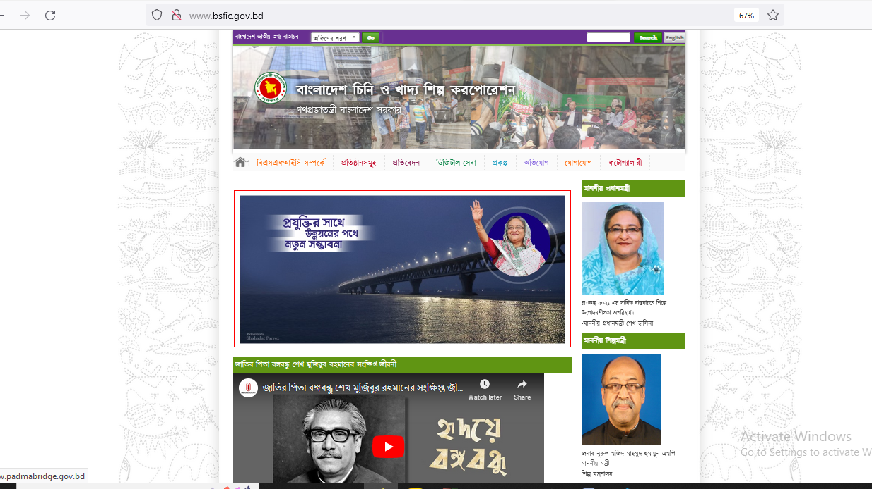

<http://www.bsfic.gov.bd/>

**Figure 3.1: Website**

1. **Advertisements:**

Advertisement is published about the mission and vision of the organization.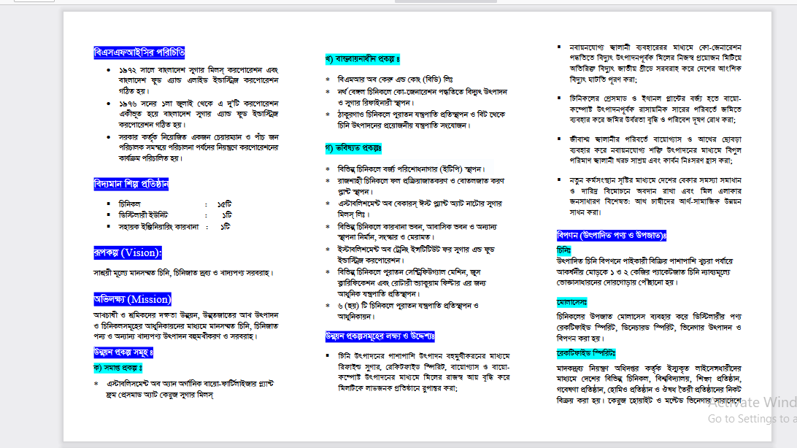

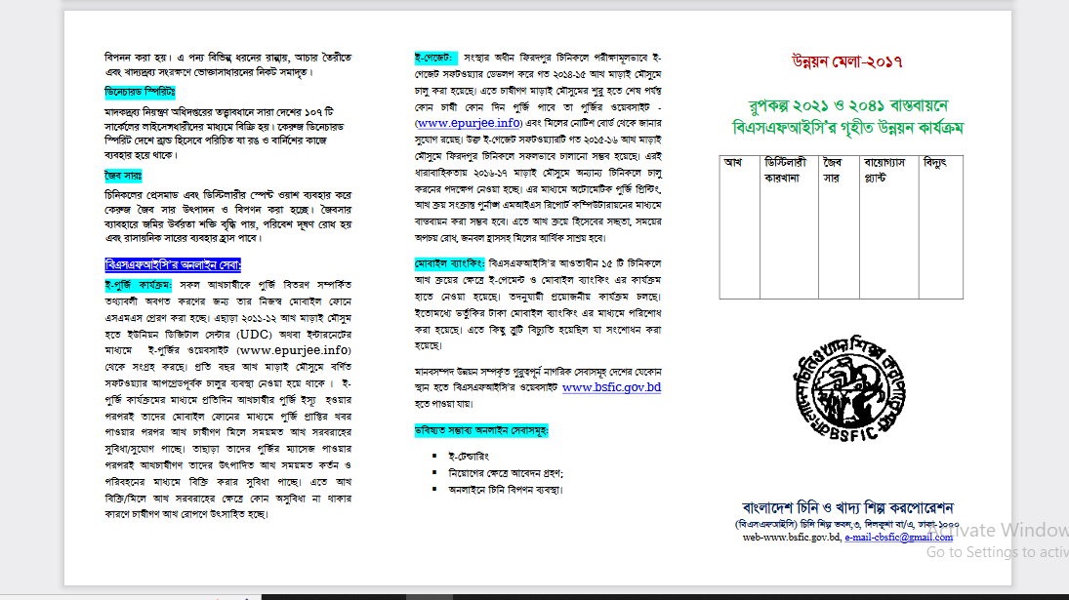

**Figure 3.2: Advertisement about mission & vision**

1. **Project progress report:**

It is important to publish project progress report every tear to clarify the profit and loss of the organization.

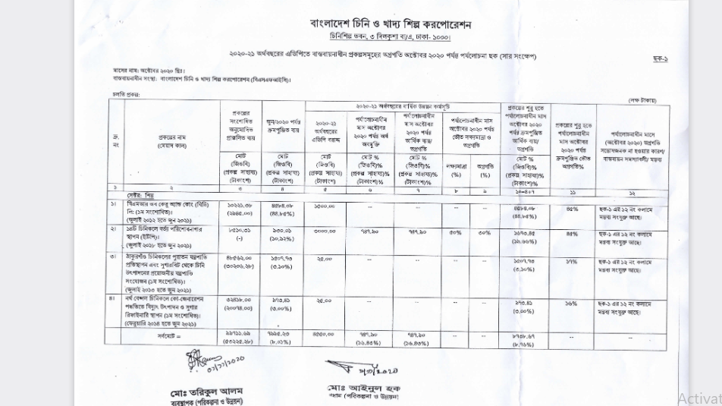

**Figure 3.3: Progress of projects under implementation in ADP for FY 2020-21 (up to October 2020)**

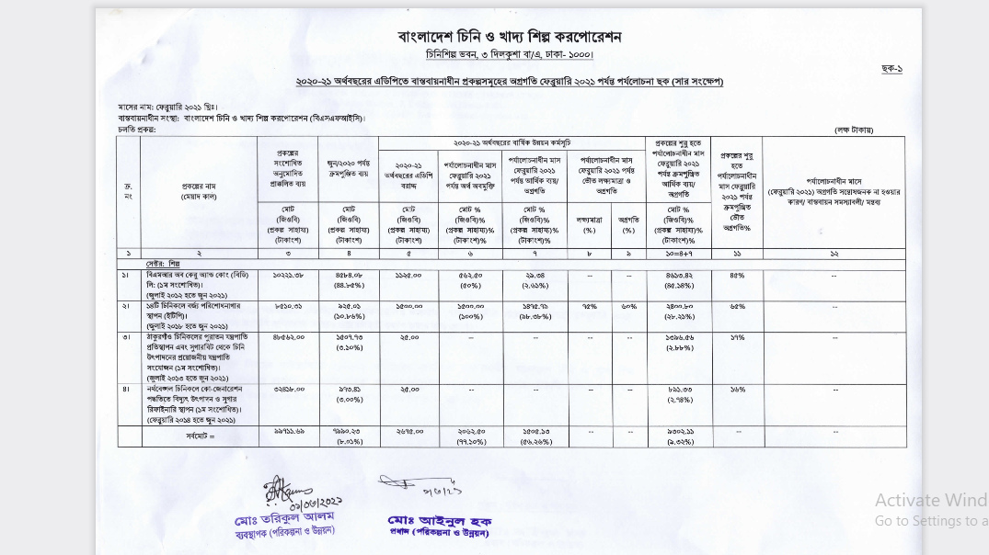

**Figure 3.4: Progress report of projects under implementation in ADP for the financial year 2020-21 up to February 2021 source:** [**http://www.bsfic.gov.bd/**](http://www.bsfic.gov.bd/)

* + 1. **On-Site Observation:**

Onsite observation is the most useful way of information collection. We visited the organization and observed the current system of the organization. We have collected so many important information about the organization.

1. Bangladesh Sugar and Food Industries Corporation or BSFIC, is a government owned corporation in Bangladesh that is charge of sugar mill.
2. The office located at Katakhali,Rajshahi.
3. There are mainly two part of the organization, one is administrative section, one is factory section.
4. Administrative section handles the administrative works of the organization.
5. Factory section doses the main work or production of sugar.
6. Around 300-400 workers works in the factory daily.
7. Of them some are permanent and others work temporarily.
8. Every day around 700 metric ton sugarcane come to the factory and produce sugar on basis of that. If the production is more than 93% then it is consider as profit otherwise it is a loss for the factory.
9. There is a mechanical department to control the mechanical system of the factory.

10. There is a civil department to solve the problem related to

this section.

11. The factory produces its own power so they don’t need to

depend on other sources.

12. All the machine of the factory were old but they works

properly.

13. We saw that every worker has to do so many work.

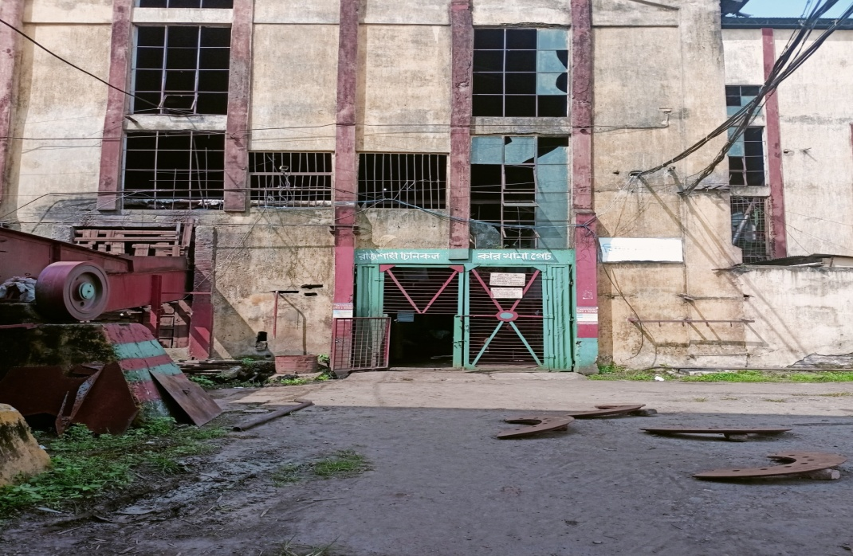

**Figure 3.5: Sugar mill factory gate.**

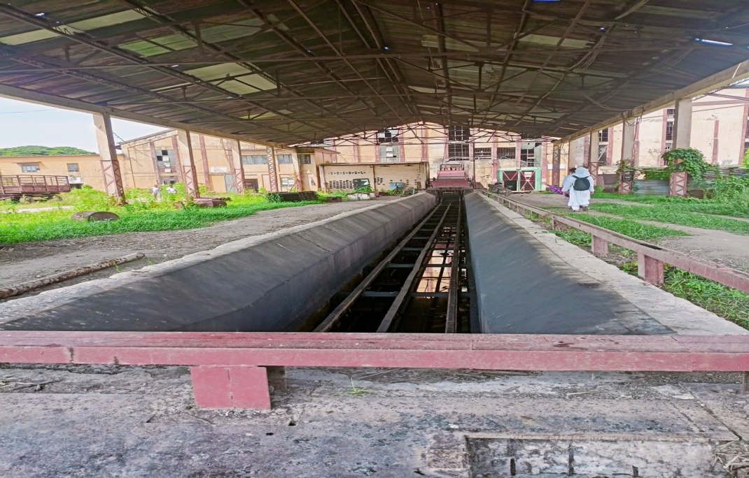

**Figure 3.6: Sugarcane first wash and crushed in this machine**

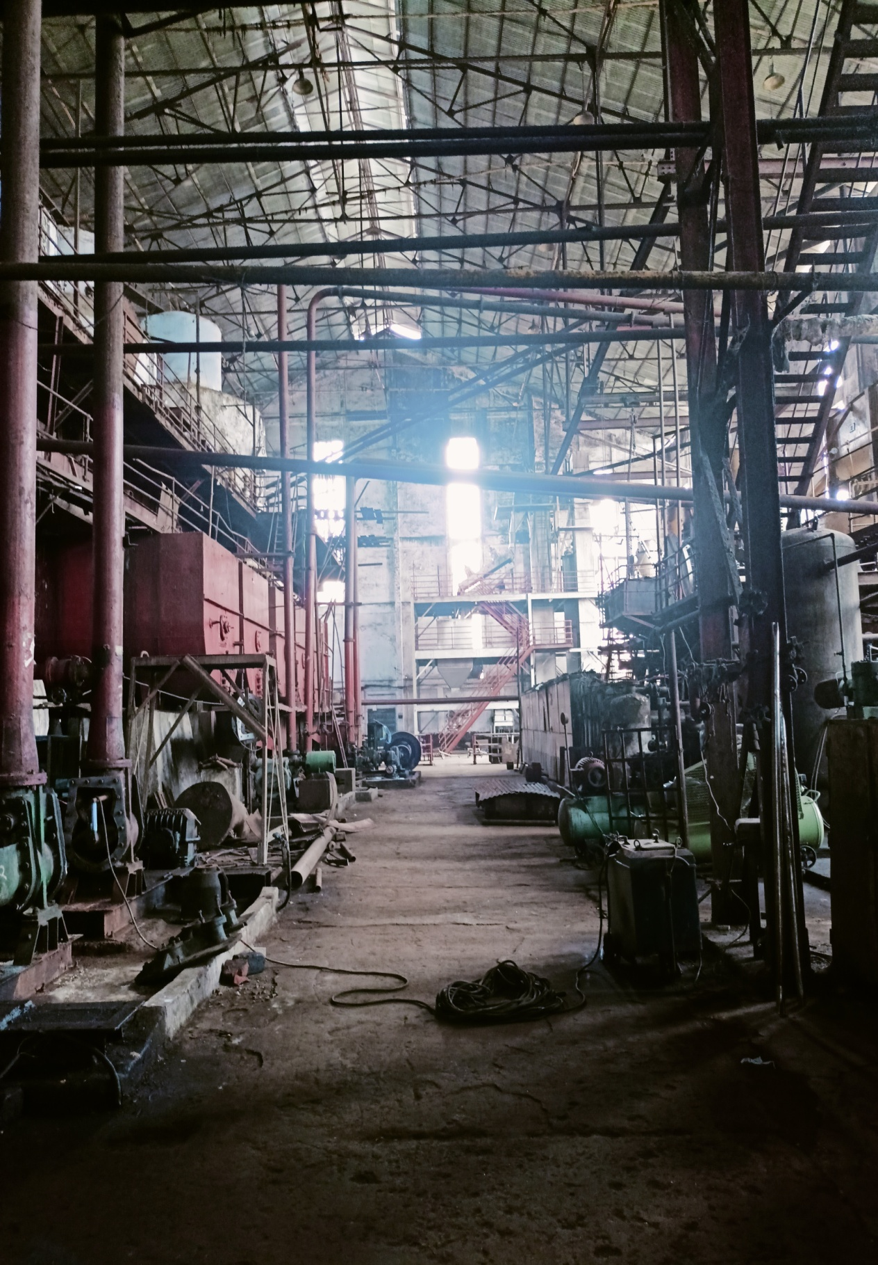

**Figure 3.7: Inside the factory (1).**

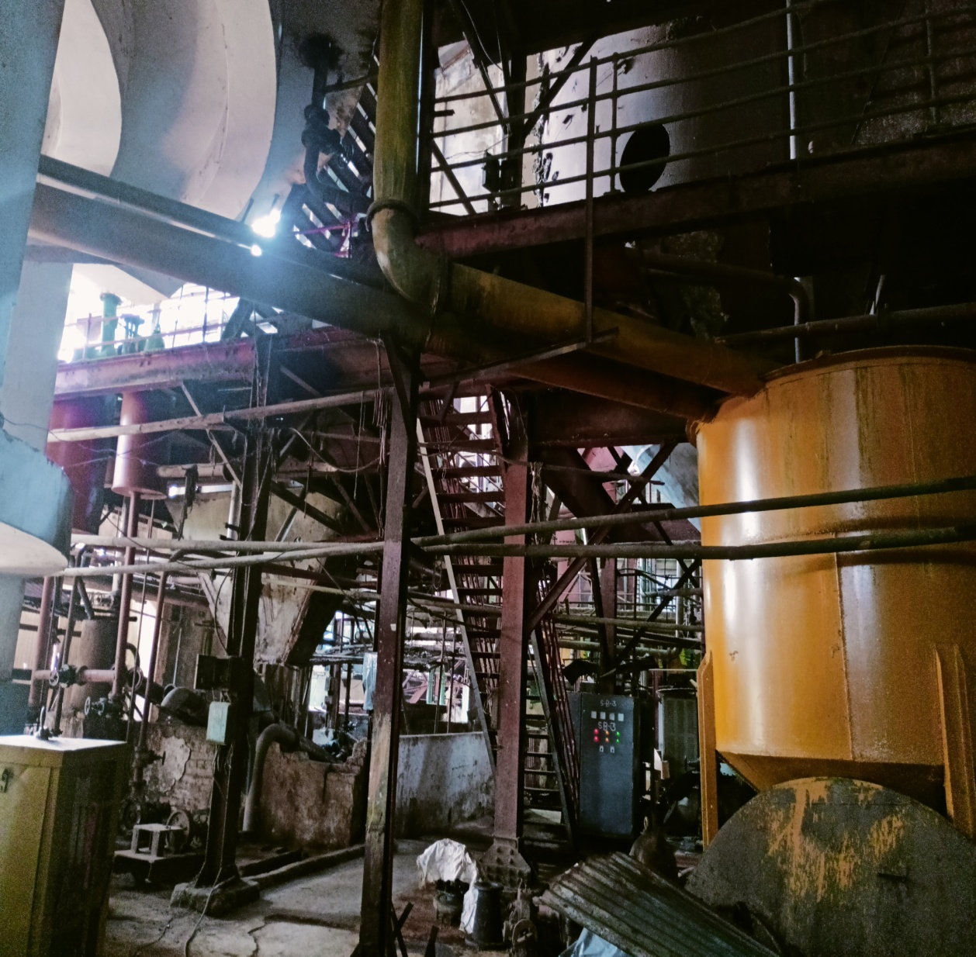

**Figure 3.8: Inside the factory (2)**

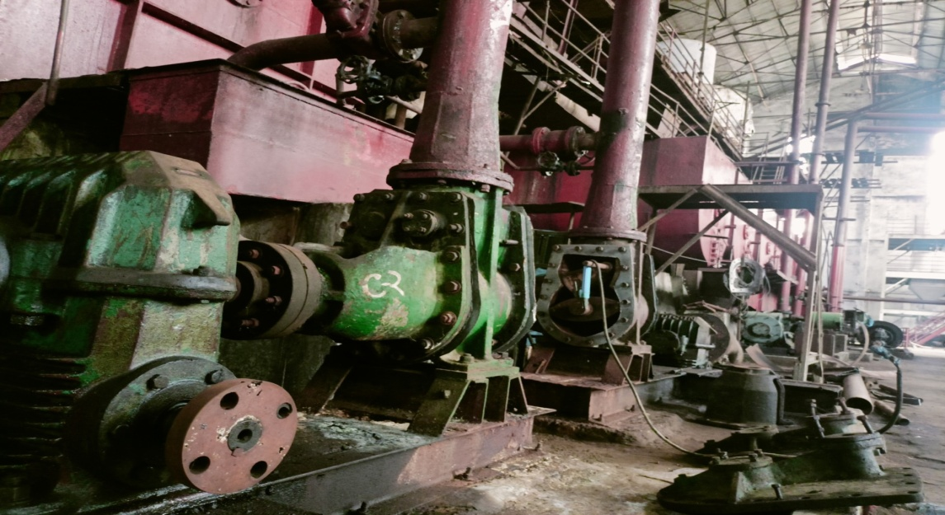

**Figure 3.8: Inside the factory (3)**

14. We saw there are many special type of vehicle to transport sugarcane.

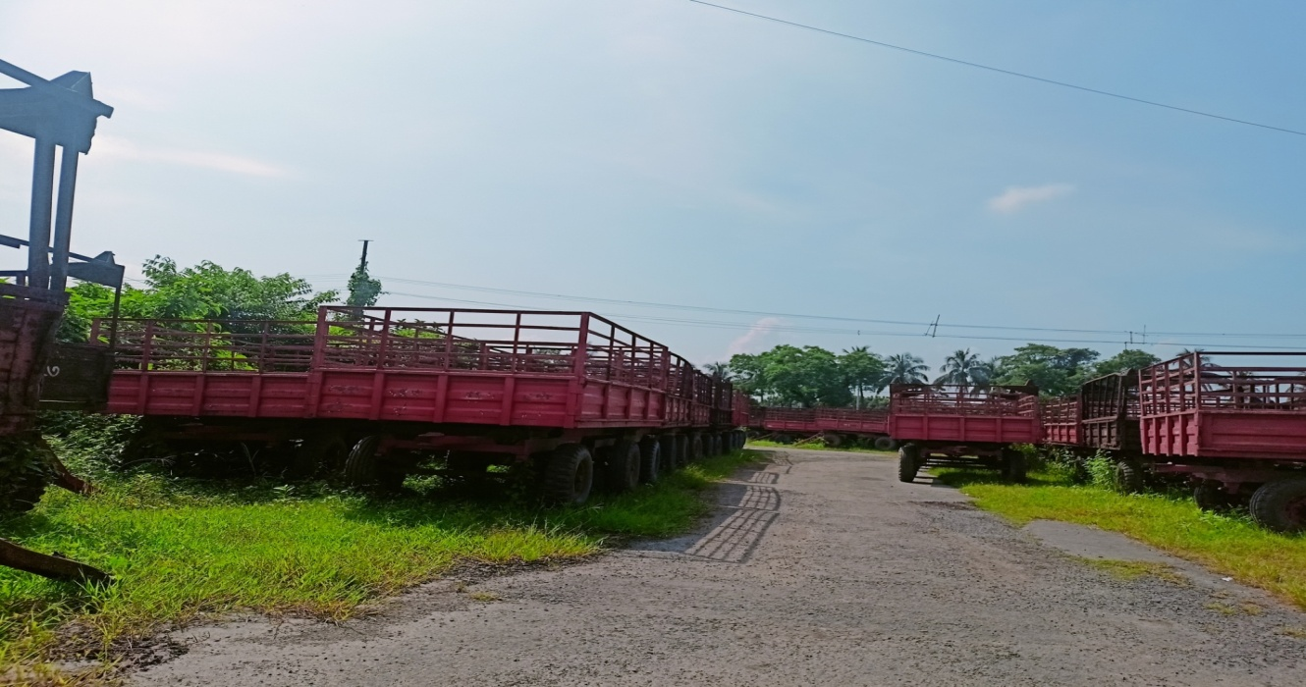

**Figure 3.8: Vehicle for Sugarcane transport**

15. Everyone were very friendly and helped us by giving

informations.

16. We were informed about their system hierarchy.

* + 1. **Interviews:**

**1.What’s the type of your organization?**

-This is a government organization to produce raw and white sugar and sell them to the people at a low cost.

**2.We Would like to know the hierarchy of your organization. Can you Please share it with us?**

-head of our organization is managing director. 4 general manager work under them. And officer deputy general manager work under them. And other agri- officers works under them.

**3. How many workers works here?**

-There are more than 300 workers work here.

**4.** **Are they all permanent?**

-No, some are temporary they work only in session when there is a huge load of work.

**5. From where you collect the sugarcane? Do you grow them here?**

-No, we collect them from the farmers. We buy them from the farmers and we also motivate them to grow sugarcane.

**6. For doing this is there any people?**

- Yes, some officers are involved to motivate the farmers and appreciate them to cultivate sugarcane.

**7. Do you have any website?**

-Yes, we have a website.

**8. Do you have any R & D section?**

-We had that but recently that section Bangladesh Sugarcrop Research Institute (BSRI) has been Separated from us.

**9. Because of this separation do you face a Problem?**

-Yes, of course. Now a day’s production has been Decreases. And to increase the production we need good quality sugarcane and that has been already good quality sugarcane and that has been already. growing in countries like Japan, China. If the BSRI would be with us, they could help us with this problem.

**10. What do you think which steps can be taken to Enrich the productivity?**

-BSRI should co operate with us. We need to motivate our farmers more and more to cultivate sugarcane.

**11. Your machines are looked old? Do you faced any problem with that?**

-Yes, they are old, and their efficiency has been decreased. It’s also a reason of decreasing the productivity.

**12. What steps did you take to solve this problem?**

- Recently we collect some improved varieties of Sugarcane from foreign and trying to grown it in our Country.

3.2.4 Organization hierarchy:

Civil

Chem

heat

Mech.

Finance

Admin

Factory

Agriculture

**Fig: Company Hierarchy of Katakhali sugar Mill Ltd**.

MD=managing director

GM=general manager

DGM=Deputy General Manager

O=officer

emp=Employee

AGM=Assistant General Manager

3.2.5 Factory hierarchy:

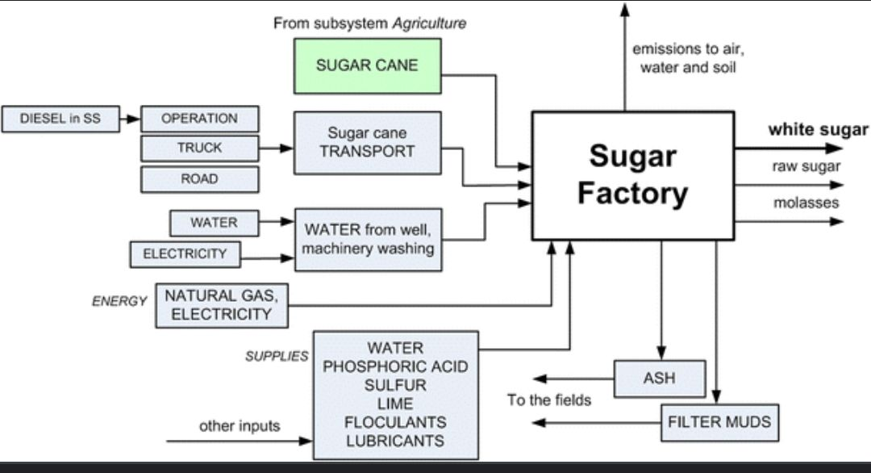

**Figure 3.10: Sugar factory hierarchy**

3.2.4 Flow chart of Sugar production from sugarcane:

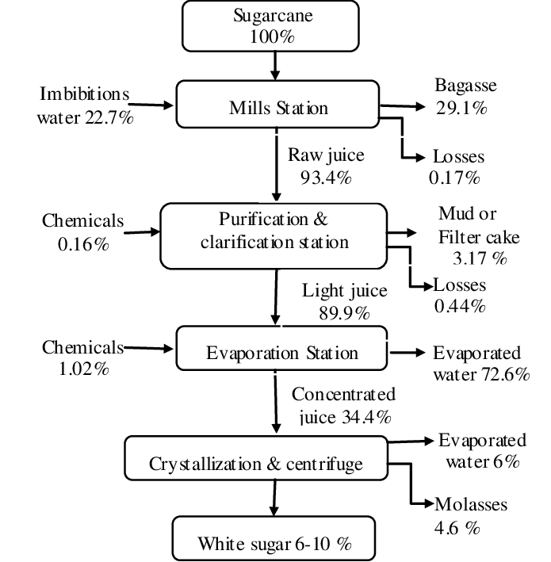

**Figure 3.11: Details of sugar production**

**3.3 Sample Questionnaires:**

**Information Collection Form (from Employee)**

1.Do you think there is enough security?

Options:

A. Yes

B. No

C. Undecided

2. On a scale of 1 to 5, how happy are you at work?

Options:

A. 5/5

B. 5/4

C. 5/3

D. 5/2

E. 5/1

3. Do you think the website needed to be improved?

Options:

A. Yes

B. No

C. Undecided

4. Organization type?

Options:

A. Profitable

B. Non profitable

C. Others

5. What do you think are the main challenges and changes for your organization in the

current time?

Answer:

6. Are there any additional comments you would like to make about your position or the

organization as a whole?

Answer:

**Information Collection Form (from Workers)**

1.Do you think there is enough security?

Options:

A. Yes

B. No

C. Undecided

2. On a scale of 1 to 5, how happy are you at work?

Options:

A. 5/5

B. 5/4

C. 5/3

D. 5/2

E. 5/1

3. Do you think your salary is enough?

A. Yes

B. No

C. Undecided

4. Are you ok with your work hour?

A. Yes

B. No

C. Undecided

**3.3 Sample Questionnaires:**

**Information Collection Form (from Employee)**

1. Do you think there is enough security?

Options:

A. Yes

B. No

C. Undecided

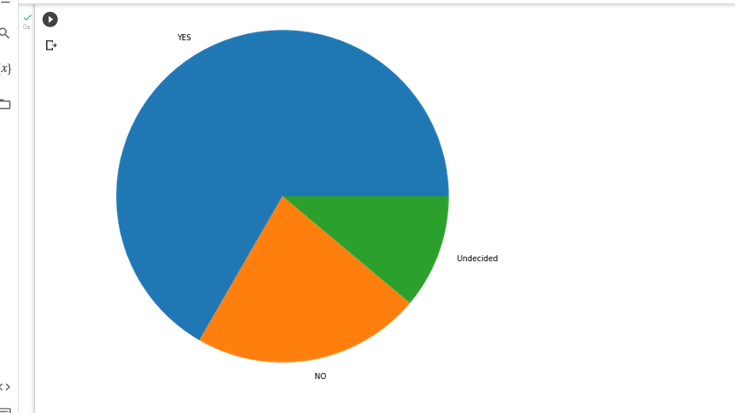

2. On a scale of 1 to 5, how happy are you at work?

Options:

A. 5/5

B. 5/4

C. 5/3

D. 5/2

E. 5/1

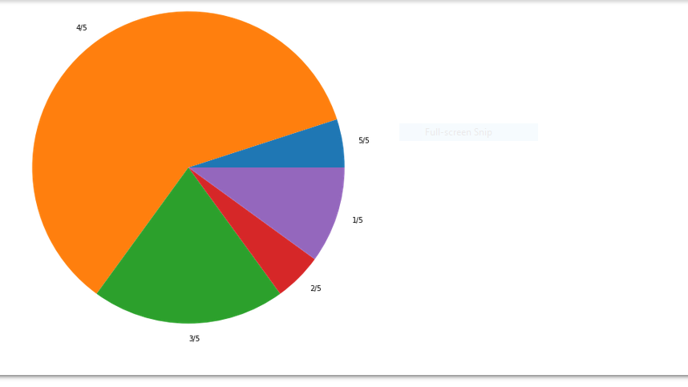

3. Do you think the website needed to be improved?

Options:

A. Yes

B. No

C. Undecided

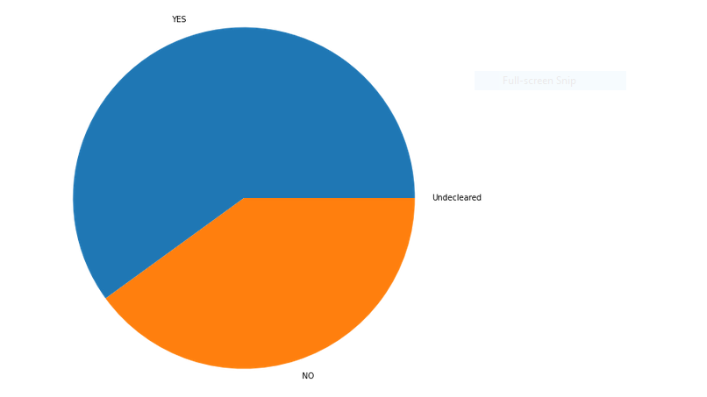

4. Organization type?

Options:

A. Profitable

B. Non profitable

C. Others

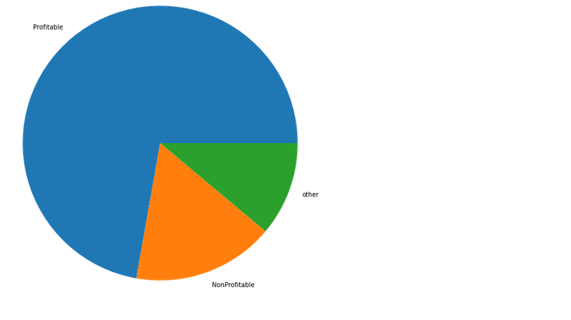

**Information Collection Form (from Workers)**

1.Do you think there is enough security?

Options:

A. Yes

B. No

C. Undecided

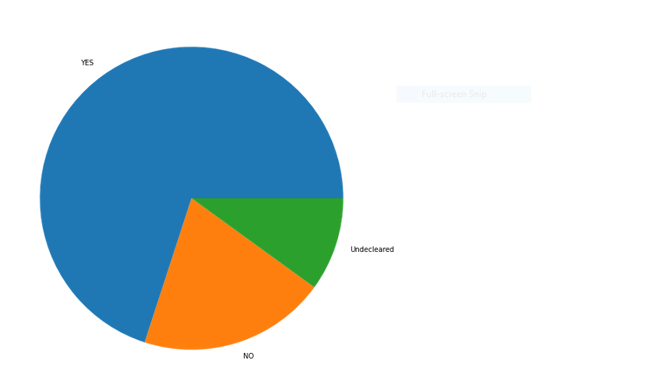

2. On a scale of 1 to 5, how happy are you at work?

Options:

A. 5/5

B. 5/4

C. 5/3

D. 5/2

E. 5/1

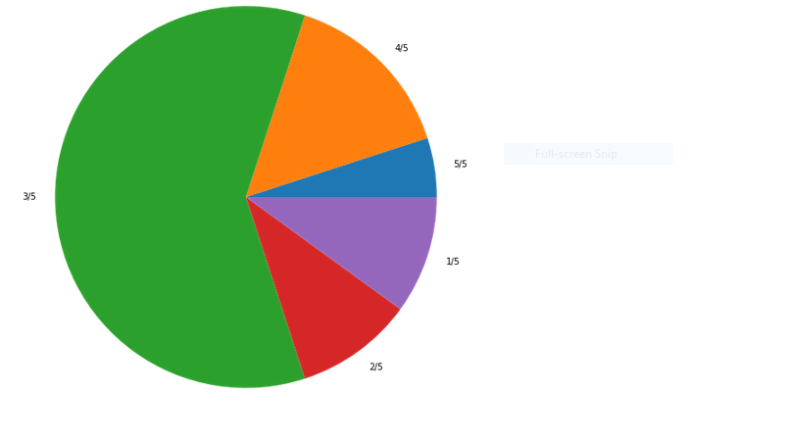

3. Do you think your salary is enough?

A. Yes

B. No

C. Undecided

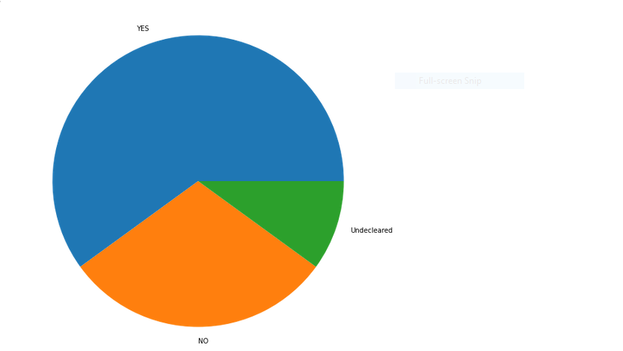

4. Are you ok with your work hour?

A. Yes

B. No

C. Undecided



**3.4 Conclusion:**

From the information we have collected we can say that, No system is error-proof but we have to learn from the error and improve the system. As an analyst after collecting all this information and analyzing it, we have found that this existing system is a promising system, but not 100% okay. It is not possible to be 100% ok of a system. We have found different flaws on basis of the information we have collected. Our next target is to propose a feasibility report on these findings**.**

**Chapter 4**

**The tools of Structured Analysis**

**4.1 Introduction:**

In the preceding chapter, we discuss the procedures used in building Rajshahi Sugar Mills Ltd. system. The goal of the system is to deliver the system in line with the user’s requirements.

Analysis is the heart of the process. In analyzing the present system,the analyst collects a great deal of relatively unstructured data through interviews, questionnaires, on-site observations, procedures manuals. The traditional approach is to organize and convert the data through system flowcharts, which support future developments of the system and simplify communication with the user. But the system flowchart represents a physical rather than logical system.It makes it difficult to distinguish between what happens and how it happens in the system.

Due to this drawback, the analyst needs something analogous to the architect’s blueprint as a starting point for system design. It is a way to focus on functions rather than physical implementation. The following tools are:

1. Data flow diagram(DFD)
2. Data Dictionary
3. Decision trees

**4.2 Data Flow Diagram :**

A DFD, also known as a “bubble chart”, has the purpose of clarifying system requirements and identifying major transformations that will become programs in system design.So, it is the starting point of the design phase that functionally decomposes the requirements specifications down to the lowest level of details. A DFD consists of a series of bubbles joined by lines.The bubbles represent the data transformations and the lines represent data flows in the system. A DFD of “Rajshahi Sugar Mills Ltd system” is shown in Fig:6.1

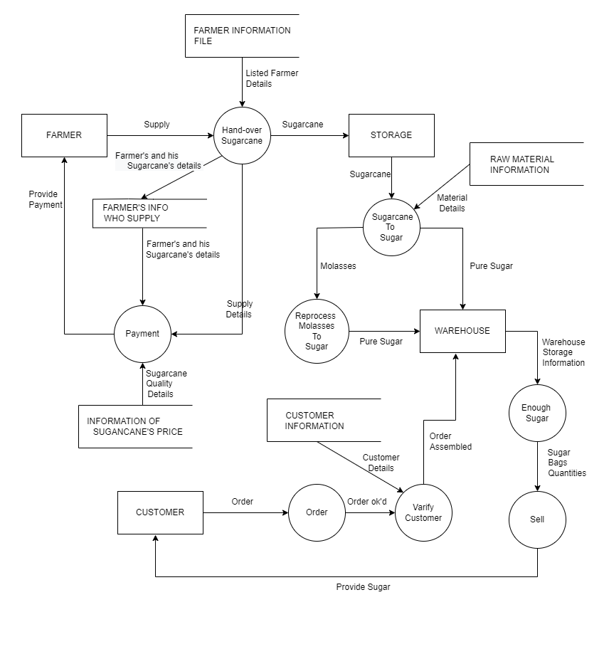

**Figure 4.1 : Data Flow Diagram of Rajshahi Sugar Mills Ltd.**

**4.3 Decision Tree:**

A policy statement can be time-consuming to describe and confusing to implement.The analyst needs to use tools to portray the logic of the policy.The first such tool is the decision tree.A decision tree has many branches as their logical alternatives.It simply sketches the logical structure based on the stated policy.Decision tree of “Rajshahi Sugar Mills Ltd. System” is shown in fig 4.2 .

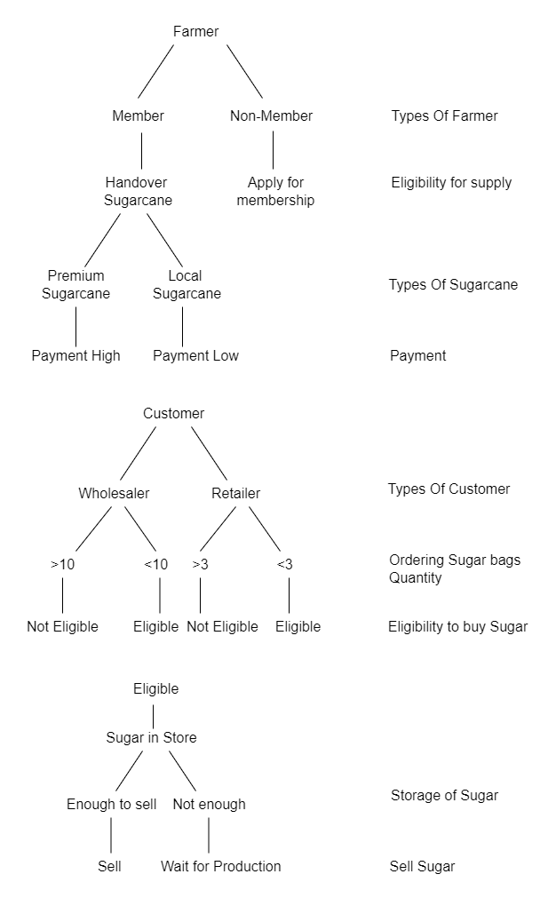

**Figure 4.2 : Decision Tree of Rajshahi Sugar Mills Ltd.**

**4.4 Data Dictionary:**

A data dictionary is a structured repository of data about data. It is a set of rigorous definitions of all DFD data elements and data structures. The Data Dictionary of ‘Rajshahi Sugar Mills Ltd’ is shown below:

| **Data Element** | **Abbreviation** | **Description** |
| --- | --- | --- |
| FARMER INFORMATION FILE | FIF | Farmer’s Name, Mobile No., Address, Sugarcane’s Species, etc are stored here. |
| HAND-OVER SUGARCANE | HOS | Only the listed farmer can hand over sugarcane to the sugar mill. This is checked here. |
| FARMERS INFO WHO SUPPLY | FIWS | The information of the farmers who supply sugarcane to the sugar mill is only stored here. |
| PAYMENT | PM | The sugar mill authority pays farmers according to sugarcane quality. |
| INFORMATION OF SUGARCANE’S PRICE | IOSQ | Price of sugarcane is stored here according to  sugarcane’s species. |
| CUSTOMER INFORMATION | CI | Customer’s name, Mobile No, Customer Type, etc are stored here. |
| ORDER INFORMATION | OI | Order information is stored here. |
| VERIFY CUSTOMER | VC | It is checked whether the customer is eligible to order. |
| ENOUGH SUGAR | ES | It is checked that enough sugar is stored in the warehouse to sell. |
| SELL | SE | It is checked whether the customer is in a wait state or not. |
| STORAGE INFO | SI | It is kept the information of the storage of sugar. |
| SELL STATUS | SS | It is kept the information of whether the customer is in a wait state or not. |

**4.5 Conclusion:**

Traditional tools have limitations. An English narrative description is often difficult for users to grasp. So, in this chapter, we showed the flowcharts that include the DFD (Data Flow Diagram) and Decision Tree of the existing system to visualize the system easily.

**Chapter 5  
Feasibility Analysis**

**5.1 Introduction**

A feasibility study is simply an assessment of the practicality of a proposed project plan or method. This is done by analyzing technical, economic, legal, operational and time feasibility factors. We have studied the present system of Rajshahi Sugar Mill and after study we have come with two potential candidate system that can solve many problems of the existing system and can also increase the productivity of the sugar mill.

**5.2 Initial Feasibility Study**

Feasibility study is carried out to select the best system that meets performance requirements. Depending initial investigation, a detailed feasibility study was done. Three key considerations are involved in the feasibility analysis are discussed below.

**5.3 Feasibility Considerations:**

There are three key considerations in the feasibility analysis of a system. They are economic, technical, behavioral.

**5.3.1 Economic Feasibility:**

Economic analysis is the most frequently used method for evaluating the effectiveness of a candidate system. More commonly known as cost benefit analysis, the procedure is to determine the benefit and saving that are expected from a candidate system and compare them with costs. If benefit outweigh cost, then the decision is made to design and implement the system.

**5.3.2 Technical Study:**

Technical feasibility centers around the existing computer system hardware, software etc. and to what extent it can support the proposed system. If we need new technical equipment, then it involves financial considerations to accommodate technical enhancements. If the budget is a serious issue, then the project is considered not feasible.

**5.3.3 Behavioral Feasibility:**

People are inherently resistant to change, and computers have been known to facilitate change. An estimate should be made of how strong a reaction the staff is likely to have toward the development of a computerized system.

**5.4 Here are our initial system analysis’s findings at Rajshahi Sugar Mill Ltd.**

**5.4.1 Current system’s needs and proposed system's approach to meet them:**

**The needs which are demonstrable are given below:**

**1.**Employees faces problems while operating machines as the machines are old enough So, they demanded to have a smooth working mechanism.

**2.** Employees talked about less production problem as machine efficiency has been decreased over time, they asked to solve this problem.

**3.** Employeesdemandtodevelopanimpactfulmanagementsystemtoboostuptheirorganization’sprosperity.

**4.**Farmers want to make sure that all the farmers under this sugar mill can have the facility of getting right guideline about their firming.

**5.** Specialist from agricultural department talked about the quality of sugarcane, they demanded to have quality full sugarcane species for increasing their sugar production rate from sugarcane.

**6.** From finance department we get to know that currently the sugar mill is in loss, every year bank loan is increasing because of interest, if it was possible to get rid of this interest or loan then the yearly production loss is ignorable.

**5.4.2 Candidate system-1:**

**1.** It will not be practically possible to change all the machines, the factory is already in loss, so we proposed for the service of machines for better working mechanism.

**2.** Efficiency will increase by doing the servicing of the machines.

**3.** A digital management system has been proposed for better management purposes for boosting up organization’s prosperity.

**4.** For guiding farmers properly a roadmap should be followed, and their sugarcane field should be visited in person and monitored strictly.

**5**. A full digitalized payment system (Mobile Banking) should be stablished.

**6**. A digital distribution system should be developed for making the distribution process easy and in a proper way.

**7.** For getting quality full sugarcane species Bangladesh Sugarcrop Research Institute (BSRI) should come forward with their research on high quality sugarcane from which sugar mill can get maximum sugar production rate.

**8.** They have enough land property. They can use their land for other purposes for earning extra money to overcome their bank loan.

**5.4.3 Candidate system-2:**

**1.**If the machines are replaced then the system will work properly. And the employees will be satisfied after having a smooth working environment.

**2.**Efficiency will increase as the machines are new. Productivity will also increase.

**3.** A digital management system has been proposed for better management purposes for boosting up organization’s prosperity. Training facility should be provided for maintaining the digital management system.

**4.** For guiding farmers properly a roadmap should be followed, and their sugarcane field should be visited in person and monitored strictly.

**5**. Establishing a Bank based payment system can be developed for the betterment of employees.

**6.** An automated system can be used for maintaining the whole production process.

**7**. A digital distribution system should be developed for making the distribution process easy and in a proper way.

**8.** For getting quality full sugarcane species they can import better quality sugarcane species from other countries.

**9.** They have enough land property. They can use their land for other purposes for earning extra money to overcome their bank loan.

**5.5 Identifying the characteristics of candidate systems:**

For finding the best candidate system we must compare the above two potential candidate systems.

**Table 5.5.1 Characteristics of two potential candidate system**

|  |  |  |
| --- | --- | --- |
| Characteristics | Candidate System-1 | Candidate system-2 |
| Management System | Computerized | Computerized |
| Payment System | Mobile Banking | Renown Bank |
| Production System | Manually | Automated |
| Distribution System | Digitalized | Digitalized |
| Storage management | Computerized | Computerized |

**Table 5.5.2Qualitative Evaluation Matrix**

|  |  |  |
| --- | --- | --- |
| Evaluation Criteria | Candidate System-1 | Candidate System-2 |
| Working Environment | Good | Very Good |
| Efficiency | Good | Very Good |
| Payment System | Good | Good |
| Employee Training | Fair | Good |
| Research Opportunity | Very Good | Not Good |
| System Management | Good | Good |

**Table 5.5.3 Performance/Cost Evaluation Matrix**

|  |  |  |
| --- | --- | --- |
| Evaluation Criteria | Candidate System-1 | Candidate System-2 |
| Efficiency | 60% | 80% |
| Employee Satisfaction | 70% | 90% |
| Machine cost | 4-5 lac BDT | 1-1.5 crore BDT |
| Payment system | 70% satisfied | 50% satisfied |
| Research Cost | 50-60 lac | N/A |
| Import Cost | N/A | 70/80 lac |

**Table 5.5.4 Weighted Candidate Evaluation Matrix**

|  |  |  |  |  |  |
| --- | --- | --- | --- | --- | --- |
| Evaluation Criteria | Weighting Factor | Candidate System-1 | | Candidate  System-2 | |
| Management | 2 | 4 | 8 | 4 | 8 |
| Machine Cost | 5 | 5 | 25 | 2 | 10 |
| Working Environment | 3 | 3 | 9 | 4 | 12 |
| Research / import (New species) | 4 | 4 | 16 | 3 | 12 |
| Payment system | 3 | 4 | 12 | 3 | 9 |
| Total=70 | Total=51 |

**5.5.5 Selecting Best Candidate System**

The system which has the highest total is considered as the best system. We have found that the candidate system-1 has the highest value. So, candidate system-1 is the best proposed system for Rajshahi sugar mill.

**5.5.6 DFD (Data flow Diagram) for best candidate system:**

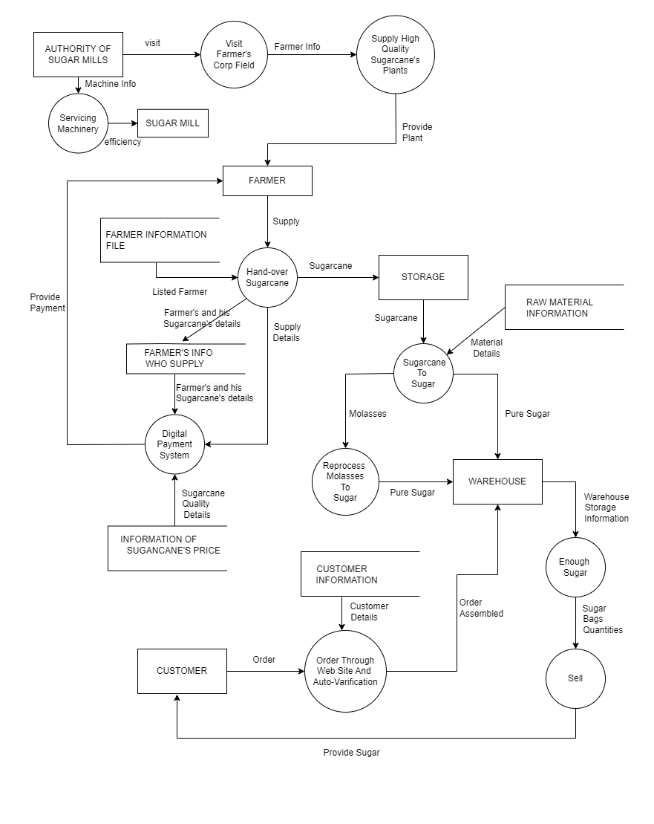

**Figure 5.1: DFD(Data flow Diagram) for best candied system**

**5.6.1 Available resources for proposed candidate system:**

**1. Hardware support:** Rajshahi sugar mill has all the machines that are required for producing sugar, regular service of them is needed for better production rate as proposed.

**2. Human resources:** The organization has enough human resources for running the sugar mill. They have their registered farmers, workers and officers for their observation. if all the members perform their duties properly the organization will develop day by day.

**3. Land property:** They have enough land for research on sugarcanes for inventing better sugarcane species.

**4. Power system:** They have their own power system for running machine which is a great system in terms for power use.

Many problems of the Rajshahi Sugar Mill will be reduced by implementing our proposed system.

Though it is not possible to change all the machine, but we can get a better working environment by doing services for the currently running machines. This will increase the productivity and the workers will be satisfied.

Efficiency will also be increased when the machines will be serviced. This will help the whole production system to minimize the organization’s loss.

Management is important for any organization, by doing this in proper way everything will be under control and every resource will be utilized properly. If everything is properly documented, then officers can get information about the system without wasting their valuable time.

Research opens the doors of new possibilities. The main obstacle can be overcome if a better-quality sugarcane species is invented.

If the proposed system is followed properly, production rate will increase. Bank load problem can not be solved overnight but our proposed system cansolve the problem gradually.

**5.6.2 Impact of the proposed system**

Steps that should be followed according to our proposed candidate system may be costly for the first-time

implementation. But once the steps are taken, production rate will be increase and this will overcome the first implementation cost. Impacts of the candidate system are listed below:

**1.** servicing of the machine may take some days, in this case production of sugar may hamper. But this is temporary and will solve a huge production problem.

**2.** More skilled human power will be required for maintaining everything systematically.

**3.** Environment should be created for research purpose. we must find whether the economic ability of the organization can afford it or not.

**4.** Employee’s should have the mentality of the betterment of the organization. Otherwise, they will not be able to accept this new candidate system because under this newly proposed system they have to do their work with more sincerity.

**5.7 Conclusion:**

In this chapter we tried to find out the solutions for existing system problems. After investigation we find that some problems can be solved by taking same basic necessary steps and just by doing duties properly. But some problems like bank loan and interest are huge problem that can’t be solved overnight or by changing the entire system. We have to solve that problem gradually.

**Chapter 6**

**Cost-Benefit Analysis**

Cost–benefit analysis (CBA), sometimes also called benefit–cost analysis, is a systematic approach to estimating the strengths and weaknesses of alternatives. It is used to determine options which provide the best approach to achieving benefits while preserving savings in, for example, transactions, activities, and functional business requirements. A CBA may be used to compare completed or potential courses of action, and to estimate or evaluate the value against the cost of a decision, project, or policy. It is commonly used to evaluate business or policy decisions (particularly public policy), commercial transactions, and project investments. In this case to analysis cost-benefit of our system Rajshahi Sugar Mills, we identify and categorized cost and benefits and analyzed.

6.1 Classification of Costs and Benefits:

1.Tangible or intangible costs and benefits: A tangible cost or benefit is a quantifiable cost or benefit related to an identifiable source or asset. Tangible costs or benefits can be directly connected to a material item used in production or to conduct business operations. Tangible costs include what a system pays its employees, inventory, computer systems, and land or equipment. An intangible cost or benefit consists of a subjective value placed on a circumstance or event in an attempt to quantify its impact. Although intangible costs and benefits are more difficult to quantify, they have a real, identifiable source. Intangible costs include a drop in employee morale or a hit to the system’s brand or reputation.

2.Direct or indirect costs and benefits: Direct costs or benefits are expenses that a system can easily connect to a specific “cost object” or “benefit object” which may be a product, department, or project. This category can include software, equipment, and raw materials. It can also include labor, assuming the labor is specific to the product, department, or project. Indirect costs or benefit extend beyond the expenses ones incur when creating a product; they include the costs or benefit involved with maintaining and running a system. These overhead costs are the ones left over after direct costs have been computed.

3.Fixed or variable costs and benefits: Fixed costs or benefits are any expenses that remain the same no matter how much a system produces. These costs or benefits are normally independent of a system's specific business activities and include things like rent, property tax, insurance, and depreciation. On the other hand, variable costs or benefits are any expenses that change based on how much a system produces and sells. This means that variable costs increase as production rises and decrease as production falls. Some of the most common types of variable costs include labor, utility expenses, commissions, and raw materials.

**6.2 Breakeven Analysis and Operating Leverage**

**6.2.1 Breakeven Analysis**

A breakeven analysis involves using both fixed and variable costs to identify a production level in which revenue equals costs. This can be an important part of cost structure analysis. A company’s breakeven production quantity is calculated by:

**Breakeven Point = Fixed Costs ÷ (Sales Price per Unit – Variable Cost per Unit)**

A company’s breakeven analysis can be important for decisions on fixed and variable costs. The breakeven analysis also influences the price at which a company chooses to sell its products.

**6.2.2 Operating Leverage**

Operating leverage is another cost structure metric used in cost structure management. The proportion of fixed to variable costs influences a company’s operating leverage. Higher fixed costs help operating leverage to increase. You can calculate operating leverage using the following formula:

**Operating Leverage = [Q x (P - V)] ÷ [Q x (P - V) - F]** Where:

* Q = number of units
* P = price per unit
* V = variable cost per unit
* F = fixed costs

Companies can produce more profit per additional unit produced with higher operating leverage.

**6.3 Categorization of Costs and Benefits**

**6.3.1 Table 1: Categorization of Costs**

|  |  |  |  |
| --- | --- | --- | --- |
| **Costs** | **Category(cost)** | **Category(cost)** | **Category(cost)** |
|  |  |  |  |
| Machineries | Fixed | Tangible | Direct |
|  |  |  |  |
| Buildings | Fixed | Tangible | Direct |
|  |  |  |  |
| Land | Fixed | Tangible | Direct |
|  |  |  |  |
| Employee Salary | Fixed | Tangible | Direct |
|  |  |  |  |
| Bonuses | Variable | Intangible | Indirect |
|  |  |  |  |
| Workers Salary | Fixed | Tangible | Direct |
|  |  |  |  |
| Computer Buying Cost | Fixed | Tangible | Direct |
|  |  |  |  |
| Furniture | Fixed | Tangible | Direct |
|  |  |  |  |
| Wiring(Initial) | Fixed | Tangible | Direct |
|  |  |  |  |
| Internet Bills | Fixed | Tangible | Indirect |
|  |  |  |  |
| Electronic Accessories | Fixed | Tangible | Direct |
|  |  |  |  |
| Sugar Cane | Variable | Tangible | Direct |
|  |  |  |  |
| Insurance(Company) | Fixed | Tangible | Direct |
|  |  |  |  |
| Vehicle | Fixed | Tangible | Direct |
|  |  |  |  |
| Machineries Maintenance Cost | Variable | Tangible | Indirect |
|  |  |  |  |
| Computer Maintenance Cost | Variable | Tangible | Indirect |
|  |  |  |  |
| Part-time Workers Wage | Variable | Tangible | Indirect |
|  |  |  |  |
| Buildings Maintenance Cost | Variable | Tangible | Indirect |
|  |  |  |  |
| Furniture Maintenance Cost | Variable | Tangible | Indirect |
|  |  |  |  |
| Electricity Cost | Variable | Tangible | Indirect |
|  |  |  |  |
| Vehicle Maintenance | Variable | Tangible | Indirect |
|  |  |  |  |
| Medical Cost | Variable | Tangible | Indirect |
|  |  |  |  |

|  |  |  |  |
| --- | --- | --- | --- |
| Insurance Cost | Variable | Tangible | Indirect |
| (Employee/Workers) |  |  |  |
| Over-time Wage of Workers | Variable | Tangible | Indirect |
|  |  |  |  |
| Sugar Cane Transport Cost | Variable | Tangible | Direct |
|  |  |  |  |
| Sugar Delivery Cost | Variable | Tangible | Direct |
|  |  |  |  |
| Electronic Accessories | Variable | Tangible | Indirect |
| Maintenance Cost |  |  |  |
| Raw Materials | Variable | Tangible | Direct |
|  |  |  |  |
| Commissions | Variable | Intangible | Indirect |
|  |  |  |  |

**6.3.2 Table 2: Categorization of Benefits**

|  |  |  |  |
| --- | --- | --- | --- |
| **Benefits** | **Category** | **Category** | **Category** |
|  |  |  |  |
| Profits(From Sugar) | Variable | Tangible | Direct |
|  |  |  |  |
| User’s Feedback | Variable | Intangible | Indirect |
|  |  |  |  |
| Employ’s Satisfaction | Variable | Intangible | Indirect |
|  |  |  |  |
| User’s Satisfaction | Variable | Intangible | Indirect |
|  |  |  |  |
| Employee’s Efficiency | Variable | Intangible | Direct |
|  |  |  |  |
| By-product | Variable | Tangible | Direct |
|  |  |  |  |
| Sugar %(in Sugar Cane) | Variable | Tangible | Direct |
|  |  |  |  |

**6.4 Conclusions:**

Above, we discussed category of benefits and costs to analysis cost-benefit. So first we discussed about different types of benefits and costs. Then, we discussed many costs and benefits and categorized them in variable or fixed cost/benefit, tangible or intangible cost/benefit, and direct or indirect cost/benefit. We discussed about breakeven point and operating leverage and how to calculate them. To analysis cost and benefit and calculate breakeven point we need those equations. And we can take decisions about our new system that is it applicable or not according to our current system. So above work, categorization and calculations are very important to take decisions about candidate systems.

Chapter 7

**The Process and Stages of System Design**

**7.1 Introduction:**

System design is a solution of how to approach to the creation of a new system. After identifying user requirements, gathered information, identifying problem and requirements we have given a feasible solution. Now, the culmination of study is a proposal summarizing the findings and recommending a candidate system for the user.

**7.2 The Process of Design:**

The design phase focuses on detailed implementation of the system recommended in the feasibility study. There are two phase of design phase. 1.Logical design and 2, Physical design.

**7.2.1 Logical Design:**

Logical design pertains to an abstract representation of the data flow, inputs, and outputs of the system. It describes the inputs (sources), outputs (destinations), databases (data stores), procedures (data flows) all in a format that meets the user requirements.

**7.2.2 Physical Design:**

Physical design relates to the actual input and output processes of the system. It focuses on how data is entered into a system, verified, processed, and displayed as output. It produces the working system by defining the design specification that specifies exactly what the candidate system does.

**7.3 Structured Design:**

Structured design is a data flow methodologies.Structured design is a data-flow based methodology that helps in identifying the input and output of the developing system. The main objective of structured design is to minimize the complexity and increase the modularity of a program. Structured design also helps in describing the functional aspects of the system.

**7.4 Structure Chart:**

**7.5 Data Tables:**

**Farmer who get Plant:**

|  |  |  |  |  |  |
| --- | --- | --- | --- | --- | --- |
| ID(pk) | Name | Sugar Species | Amount of Plant | Address | Mobile No |
| 1 | Mohi | A Type | 500 | Rajshahi | 01789498579 |
| 2 | Nayeem | A typpe | 600 | Rajshahi | 01787598579 |
| 3 | Jadu | B type | 345 | Rajshahi | 01787898579 |
| 4 | Madu | A type | 689 | Rajshahi | 01787408579 |
| 5 | Kadu | B type | 1023 | Rajshahi | 01787492579 |

**Farmer Information file:**

|  |  |  |  |
| --- | --- | --- | --- |
| ID(pk) | Sugar in Each Area(per m^2) | Sugar Species | Listed |
| 1 | 300 | A Type | Y |
| 2 | 234 | A typpe | N |
| 3 | 345 | B type | Y |
| 4 | 256 | A type | Y |
| 5 | 345 | B type | Y |

**Farmer who supply:**

|  |  |  |  |  |  |
| --- | --- | --- | --- | --- | --- |
| ID(pk) | Name | Sugar Species | Amount of Plant | Address | Mobile No |
| 1 | Mohi | A Type | 500 | Rajshahi | 01789498579 |
| 2 | Nayeem | A typpe | 600 | Rajshahi | 01787598579 |
| 3 | Jadu | B type | 345 | Rajshahi | 01787898579 |
| 4 | Madu | A type | 689 | Rajshahi | 01787408579 |
| 5 | Kadu | B type | 1023 | Rajshahi | 01787492579 |

**Customer Information file:**

|  |  |  |  |  |  |
| --- | --- | --- | --- | --- | --- |
| ID(pk) | Name | Type | Pre total order(kg) | Address | Mobile No |
| 1 | Mohiuddin | R Type | 500 | Rajshahi | 01739498579 |
| 2 | Naumuddin | R typpe | 600 | Rajshahi | 01787598579 |
| 3 | Jadullah | E type | 345 | Rajshahi | 01767898579 |
| 4 | Madullah | E type | 689 | Rajshahi | 01789408579 |
| 5 | Kadullah | R type | 1023 | Rajshahi | 01787492579 |
| 6 | Jalaluddin | R type | 1233 | Rajshahi | 01787492570 |

**Sell Status:**

|  |  |  |  |  |
| --- | --- | --- | --- | --- |
| ID(pk) | Name | Sell Status | Address | Mobile No |
| 1 | Mohiuddin | D | Rajshahi | 01739498579 |
| 2 | Naumuddin | D | Rajshahi | 01787598579 |
| 3 | Jadullah | N | Rajshahi | 01767898579 |
| 4 | Madullah | N | Rajshahi | 01789408579 |
| 5 | Kadullah | D | Rajshahi | 01787492579 |
| 6 | Jalaluddin | N | Rajshahi | 01787492570 |

**Order information files:**

|  |  |  |  |  |
| --- | --- | --- | --- | --- |
| ID(pk) | Name | Listed | Sugar Species | Sugar in Each Area(per m^2) |
| 1 | Mohi | Y | A Type | 300 |
| 2 | Nayeem | N | A typpe | 234 |
| 3 | Jadu | Y | B type | 345 |
| 4 | Madu | Y | A type | 256 |
| 5 | Kadu | Y | B type | 345 |

**Row material information:**

|  |  |
| --- | --- |
| ID(pk) | Water per tank (L) |
| 1 | 300 |
| 2 | 234 |
| 3 | 345 |
| 4 | 256 |
| 5 | 345 |

**Information of sugar can price:**

|  |  |  |
| --- | --- | --- |
| ID(pk) | Sugar Species | Storage Ready |
| 1 | A Type | Y |
| 2 | A typpe | N |
| 3 | B type | Y |
| 4 | A type | Y |
| 5 | B type | Y |

**Storage information:**

|  |  |
| --- | --- |
| ID(pk) | Storage Bags |
| 1 | 200 |
| 2 | 100 |
| 3 | 200 |
| 4 | 300 |
| 5 | 500 |

**7.6 E-R Diagram:**

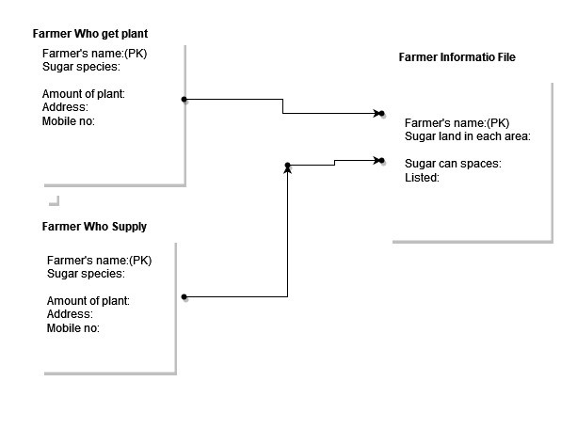

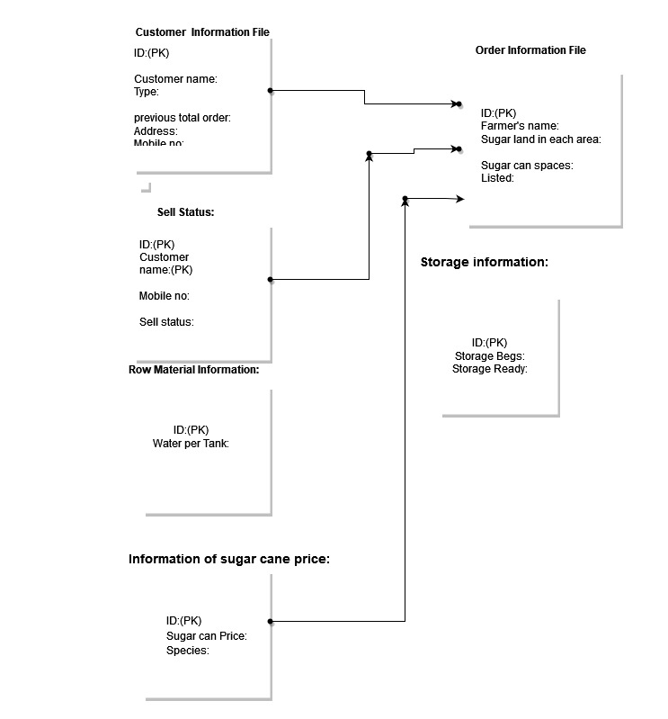

**7.7 Conclusion:**

Structure design makes it easier to identify the data structural design of the system.Structured analysis primarily focuses on the data needed to ensure a system model performs its functions. As a result, it requires a logical approach. Engineers and architects train such skills extensively. This allows them to convert project requirements into a model or program that meets the client's needs. Its graphical nature makes it a good communication tool between user and analyst or analyst and system designer. That’s why we did the analysis in this chapter.